Problem Statement
Building a Robust Conversational Intelligence pipeline for Body-Worn Camera and real-world interaction audio using ASR, and Speaker Diarization.
Background:
Body-worn camera recordings, public confrontations, and real-world conversational audio contain valuable information for incident review, compliance auditing, behavioral analysis, and conversational intelligence.
However, these recordings present significant challenges:
- Long periods of silence
- Traffic and environmental noise
- Far-field speech
- Speaker overlap
- Rapid turn-taking
- Emotionally escalated conversations
- Variable recording quality
Traditional speech processing pipelines often perform well on clean datasets but degrade substantially under these operational conditions.
As a result, obtaining an accurate speaker-attributed conversational timeline remains a difficult task.
Problem:
Given a real-world interaction video recording, automatically generate an accurate, timestamped, speaker-aware conversational timeline that can be used for downstream reasoning and analysis.
The system must:
- Produce high-quality speech transcription
- Identify and separate multiple speakers
- Align spoken content with precise timestamp
- Attribute each utterance to the correct speaker.
- Understand interaction structure
- Detect procedural/SOP events
- Verify whether required procedures were followed
- Analyze escalation/de-escalation
- Remain robust under real-world operational conditions

What are we working on:
We are trying to solve this problem on several fronts:
- Dataset and ground truth construction
- Audio Processing pipeline
- Dataset analytics and benchmarking metadata
- Different Diarization and Speech-to-Text methods and techniques
- Post-processing to be followed to correct the conversational timeline produced
We are following several different pipelines to try and compare which techniques and routes are better suited to the task, identifying which metrics are helping us observe the attributes and important orthogonal features that help improve our pipeline.
One such pipeline which we are discussing is:
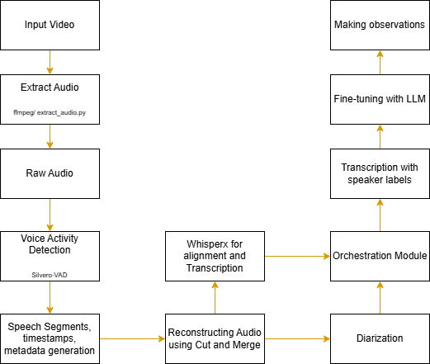
And the other is:

What are we focusing on next:
We are trying to implement different pipelines and architectures to see which are better suited to improving the metrics we are defining for our task.
Reading different literature made us realize the problems and issues which the operational data causes us we need the following:
- Proper denoising and pre-processing
- Better diarization which can support generalization and not focus on a single clean dataset
- Robust features and architecture which helps identify the bottlenecks in the pipeline and improve on those fronts
- Correcting speaker labels diarization using LLM fine-tuning

